Name: Sarada Prasad Jena

Email Id: sarada.jena1988@gmail.com Mobile No: +919819234479

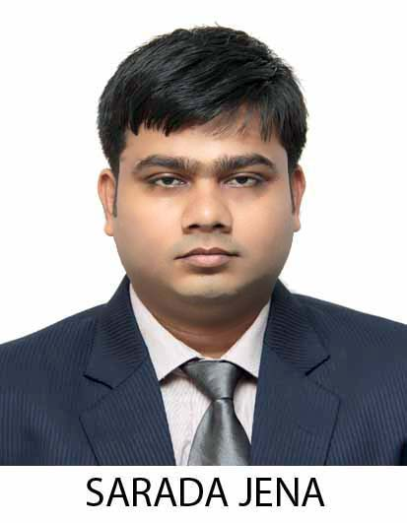

Career Objective:

To serve organization by making optimum utilization of my skills & knowledge and grow with the organization.

Summer Training & Project Details:
Company : Siemens ltd
Location : Kolkata
Duration : 3 Months [March 12, 2013 to May 31, 2013]
Project Title : Bank Guarantee and Proforma Invoice of Commercial Department
Employment Details:

Name of Company | Designation | Job Profile | Work Exp in Months
Anukul Enterprises | Maintenance Engineer | Control and Instrumentation Jobs | 20

Additional Qualifications:
- Vocational Training in Hardware and Networking in Central Tool and Training Center.
- Have good knowledge on Microsoft Office.
Educational Qualifications:

Degree | School / College Name | Board /  University | Year of Passing | CGPA / %
PGPM [Major in Finance and Minor in Marketing] | IBS Mumbai | IBS Mumbai | 2014 | 6.51
Grad. [B.Tech in Applied Electronics & Instrumentation] | Silicon Institute of Technology | BPUT | 2010 | 6.54
H.S.C. | Zinc Smelter Senior Secondary School | CBSE | 2005 | 67.6
S.S.C. | Delhi Public School | CBSE | 2003 | 84.2
MBA | ICFAI Dehradun | IUD | 2014 8.4

Achievements:
- Participated in State Level Subroto Mukherjee Cup for Football.
- Winner of Trekking Event organized by YNC.
- Winner of LAN Games in Graduation College Techfest.
- Winner of Basketball and Volleyball Games in College.
- Contributed to Blood Donation Camp eventually participating and organizing it.

Extra-Curricular Activities:
- Functioned as an active member of Campus Life Workshop and college Techfest conducted by Silicon Institute of Technology in 2009.
- Active member of Blood Donation Camp Organized by Red Cross Blood Bank at Silicon Institute Of Technology In September 2008.
- Participated In:
- All India Scout Association during my school days.
- Science Exhibition.
- Inter School Debate Competition.
- Inter School Gk Competition.
Hobbies / Interests:

My hobbies are exploring different places, riding motobikes,surfing internet,watch movies,computer lan games.
Personal Details:

Date of Birth : 20th Feb 1988

Languages Known : English , Hindi , Oriya

Current Address : Qr.No -C/141,
Nalconagar,
Angul-759145,
Odisha.

Permanent address : At/PO-Lankapara,
Via-Tyendakura,
PS-Tirtol,
Dist-Jagatsinghpur
Pin-754134
Odisha.

